DIAGRAMING THE PLOT OF A SHORT STORY

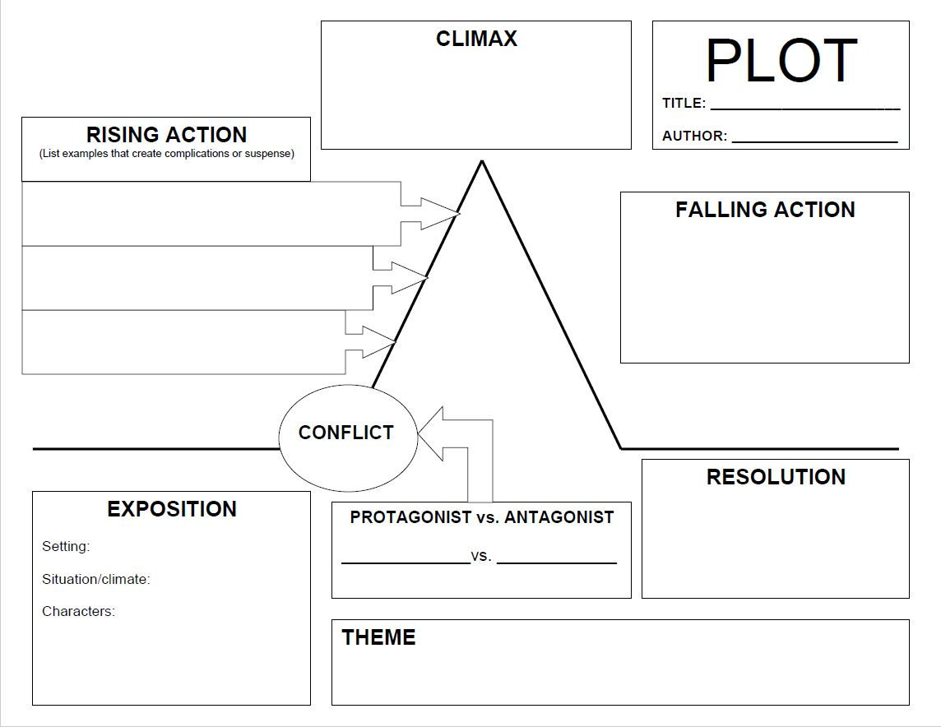
Name:________________________
Date:_________________________
Period:________________________
Title:__________________________
Author:________________________
DIAGRAMING THE PLOT OF A SHORT STORY (KEY: Aladdin)

EXPOSITION
Characters:
- Aladdin
- Jasmine
- Iago
- Japhar
- Aboo
- The Sultan
Setting:
- Location – Agribah
- Time-Period – Pre-Technology
- Culture – Middle-Eastern
Situation/Climate:
- Japhar gets Aladdin to go to the Cave of Wonders and get the lamp.

RISING ACTION
- Aladdin meeting Genie
- Becoming Prince
- Falling in love with Jasmine
- Having lamp stolen by Iago
CLIMAX
- Aladdin fights Japhar who turns into a giant snake, and defeating him by tricking him into becoming a genie.
FALLING ACTION/RESOLUTION
- Genie gets his freedom
- Jasmine choosing to marry Aladdin.

